VCLSD TBT Form

Grade Level ______________________ Meeting Date_______________________________

Participants
Evidence of Need / Based on Classroom Performance:

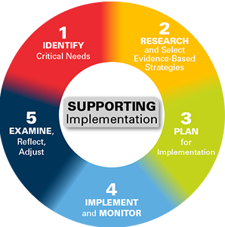
Interventions Attempted:

Current Students of Concern Intervention Focus

