How to make this site your Home Page if using Internet Explorer
(It will automatically open when you open the Internet.)
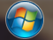
- Click on the Windows icon on the bottom toolbar

- Click on “Control Panel”
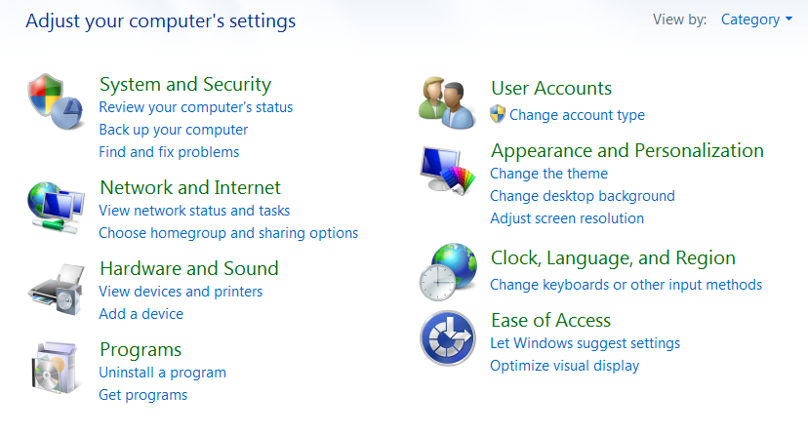
- Click on “Network and Internet”

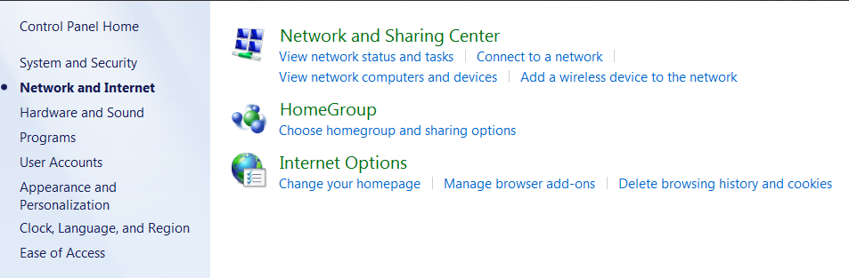
- Go to “Internet Options” and click “Change your homepage”

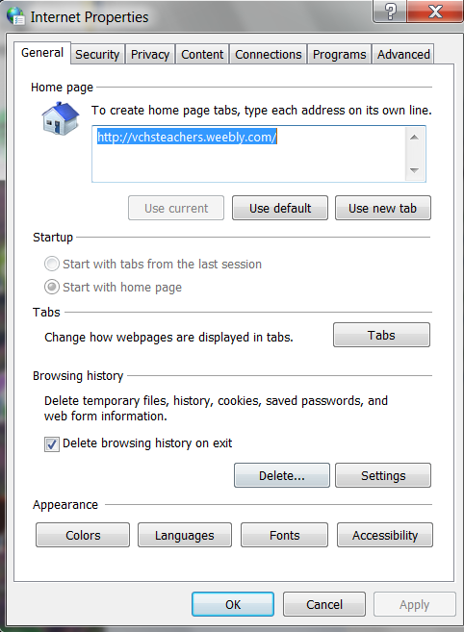
- Type www.vchsteachers.weebly.com in the box
and click “Apply” then click “OK” at the bottom.

How to make this site your Home Page if using Google Chrome
(It will automatically open when you open the Internet.)
- Click on the Google Chrome icon
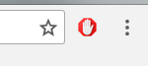
- Click on the three dots at the top right of your screen

- Scroll down and click on “Settings”
- Scroll down to the “On Start Up” section and click beside
“Open a specific page or set of pages”
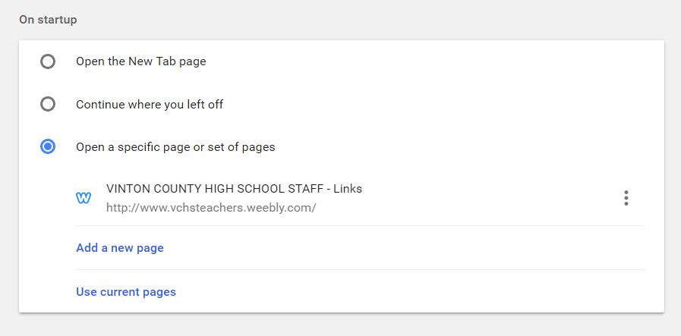
- Click on the three dots and go to edit

- Type www.vchsteachers.weebly.com/ and click “SAVE”

